Background information on St Stephen’s Art Centre



St Stephen’s Church
St Stephen’s Road, Cheltenham GL51 3AD

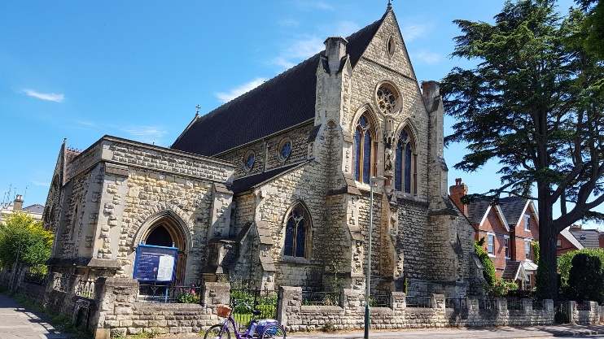
Background
St Stephen’s is the Church of England Parish Church of Tivoli, Cheltenham, in the Diocese of Gloucester. St Stephen's is located in Cheltenham, Gloucestershire at St Stephen's Road. The church was built in 1873 as a Chapel of Ease to Christ Church (Cheltenham), to cater especially for the poor working folk of Tivoli. It is a grade II* listed building (https://historicengland.org.uk/listing/the-list/list-entry/1387915?section=official-list-entry) by the architect John Middleton. It originally consisted of what is today the Choir and Sanctuary area, but due to its popularity it was extended to its present dimensions by 1883. The interior of the church is far more impressive than its exterior appearance might suggest. It is listed because it is particularly good quality and a well detailed and executed example of late Victorian Gothic by a nationally renowned architect.
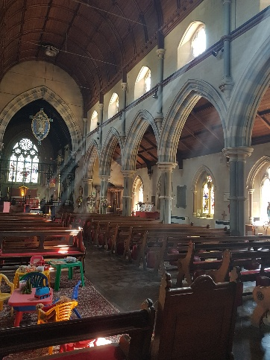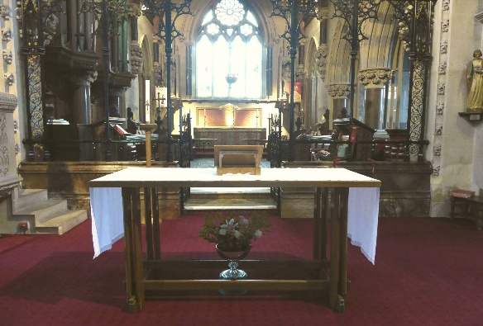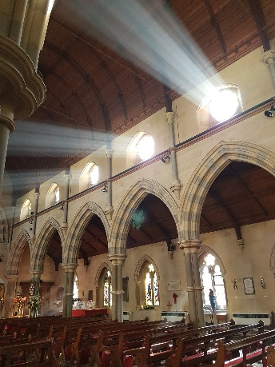
It is one of five churches in the South Cheltenham Team Ministry and is the smallest parish in the Cheltenham Deanery. The style of worship is Anglo-Catholic and it is particularly important in the Gloucester Diocese as it is the only inclusive Anglo-Catholic church, that is accepting women priests.
St Stephen’s church has some on street parking and is walking distance from the 94, 95, 96 buses which stop at the Park Campus (9 minute walk) or Cheltenham Spa Railway station (15 minute walk).
The main church building is a large central area in the Nave with pillars and side walkways/additional seating. There is a grand piano and an organ (to be restored). There is seating capacity for 180 on benches with additional seating in the side aisles. The Meeting Room (7m x 8m) is equipped with tables and chairs and an upright piano in a light room suitable for small group meetings or activities. There is a sink and drink making facilities. There are currently two toilets, one with regular public access.
The church stands alone with no church hall or vicarage.
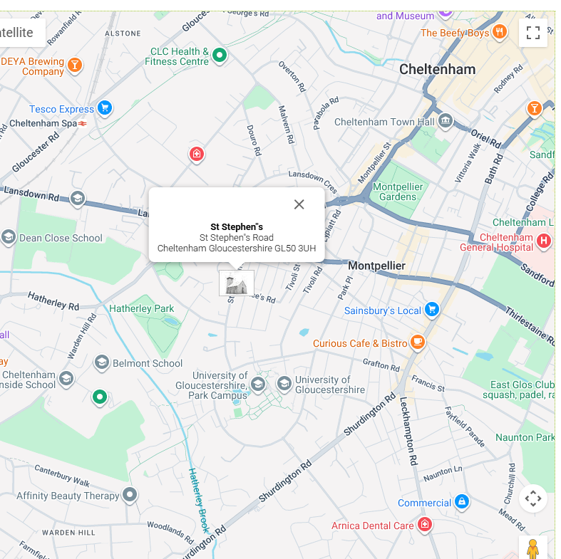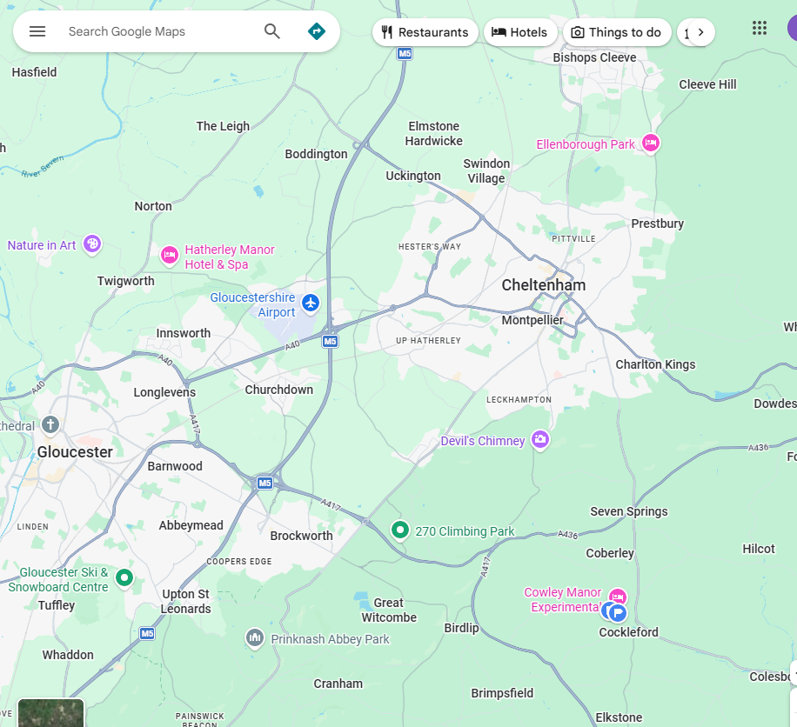

St Stephen’s church has pre-Raphaelite stained glass windows, the oldest War Memorial in Cheltenham in the Memorial Chapel off the Meeting room along with a cross from a grave on the Somme. On the west wall is the Apostles frieze.
The Organ having been built by Norman and Beard is a fine example of this excellent organ builders and once restored will give many years of reliable service. It was built in 1912. Norman & Beard Ltd., were probably the largest organ-building firm of their day, based in Norfolk in England. They had gained a very enviable reputation for quality craftsmanship even by 1912.
Reasons for change
Currently St Stephen’s is funded mainly by the congregation and is running at a significant loss. It is cold, the décor is dated and the lighting is only adequate. There is no disabled access and only one regularly accessible toilet which is not suitable for disabled. The building has excellent acoustics and a fine organ. Change is needed to ensure that the congregation can continue to worship in this building and that this fine, architecturally important church and significant organ can continue to be used in a Christian venue.
Options for change
- Allow the church to close and the congregation move to another church. This would mean there is no longer an Anglo-catholic church in the county which welcomes women priests
- Merge with another church. Other churches in the group have established congregations and individual styles of worship. The other Anglo-catholic churches in Cheltenham are in other church groups; merging would not be straightforward and probably would not be welcomed as all churches find finances difficult and would most likely not be in a position to take on one struggling financially.
- Make basic changes to improve the heating, lighting, disabled access and décor to encourage groups to use the space. This is an option and it would need to be explored along with similar offers across Cheltenham. It would be important to ensure that this basic change project was viable.
- Make basic changes and restore the organ. The benefit of this option is that the organ is unique and high quality. It would add value not only to the congregation but also to organists and musical groups across the county. It would be anticipated that this would create more revenue in the long term.

Budget forecast
At the moment St Stephen’s is running at a £10,000 loss per annum. It is estimated, that in order to be financially viable both the Meeting Room and the Nave would need to be hired out on a regular basis.

